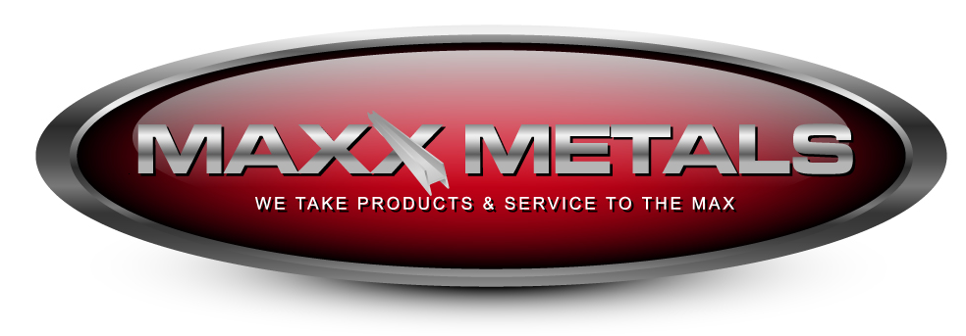

355 Quarry Road
San Carlos, California 94070
Phone (650) 654-1500 Fax (650) 654-1501
Email Sales@MaxxMetals.com
www.MaxxMetals.com

We’re committed to making your job easier. We provide a variety of metal products to meet your needs: galvanized, hot roll, cold roll, stainless, and aluminum.

Pressed for time? We can cut and punch your order fast! Can’t find the material you need? Let us help and we’ll deliver whenever you need it.

Call us at (650) 654-1500 or fax us your
Order or Quote today (650) 654-1501 Sales@MaxxMetals.com

See how easy doing business can be, at Maxx Metals we provide extraordinary service. We’re proud of our friendly and knowledgeable sales staff. We’ll expedite your will call order just in time to complete your unique job.

Also, we accept cash, checks, American Express, Master Card, Visa and Discover Card.
Andy Wallace

355 Quarry Road
San Carlos, California 94070
Phone (650) 654-1500 fax (650) 654-1501
Email Sales@MaxxMetals.com
www.MaxxMetals.com

Galvanized  Flat bar  Angle  Channel  Wide flange beam  I beam  Diamond plate  Plates cut to size  Sheets  Round bar  Square bar  Round tube  Square tube  Rectangular tube  Pipe sch 40  Pipe sch 80 | Carbon Steel  Flat bar  Angle  Channel  Wide flange beam  I beam  Diamond plate  Plates cut to size  Sheets  Round bar  Square bar  Round tube  Square tube  Rectangular tube  Pipe Sch 40  Pipe Sch 80  Half round  Half oval  Tee bar  Molded cap rail | Stainless  Flat bar  Angle  Channel  Diamond plate  Plates cut to size  Sheets  Round bar  Square bar  Round tube  Square tube  Rectangular tube  Pipe Sch 40 | Aluminum  Flat bar  Angle  Channel  Diamond plate  Plates cut to size  Sheets  Round bar  Square bar  Round tube  Square tube  Rectangular tube  Pipe Sch 40

PROCESSING-
FOR YOUR IMMIEDIATE AND UNIQUE JOBS
Cut to length Forming
Shearing Rolling
Punching Plate Cutting

WILL CALLS – JUST IN TIME CUSTOMIZED ORDERS
DELIVERIES – OUR GOAL BE THERE WHEN YOU EXPECT IT.

